A chained conditional has instructions that follow one another subsequently (back to back on the same level) whereas a nested conditional goes down levels on each instruction, usually with the following instruction nested within the else statement of the first level and stepping in deeper from there.

An example of a chained conditional:

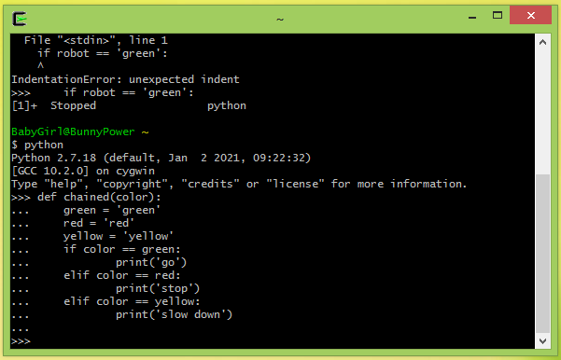

An example of a nested conditional:

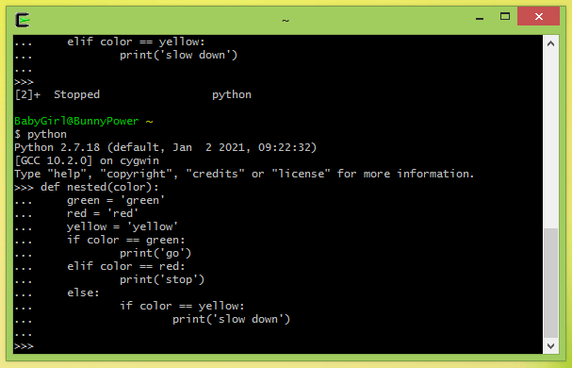

My strategy for avoiding deeply nested conditionals is not to extend another if statement in an else statement and set it in one level deeper, but rather to follow it up with an else if statement on the same level instead as this avoids nesting, as indicated in my example below:

An example of a nested conditional:

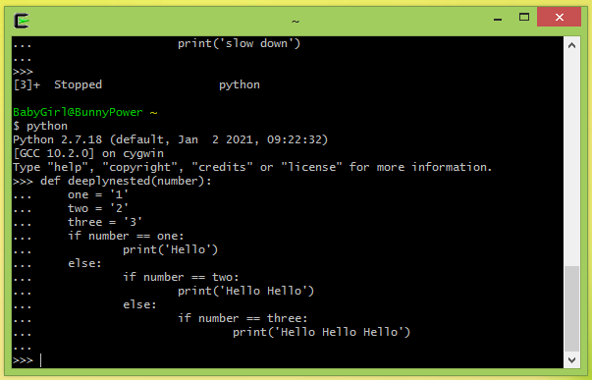

How I modify it to a single chained conditional:

